Seminars on discipline Engineering Bioprocesess
Seminar 1. History of Bioprocesess
Meaning of Bioprocesess from industrial, commercial activity.
Stages in Bioprocess development
Main products
Biopolymer
- Biopolymers are polymers that are produced by or derived from living organisms, such as plants and microbes, rather than from petroleum, the traditional source of polymers.
- The primary sources of biopolymers are renewable.
- Many biopolymers are biodegradable, but not all. Polythioesters are non-biodegradable by microorganisms, which represent a novel non-biodegradable bioplastic material.
- Biopolymers consist of monomeric units that are covalently bonded to form larger molecules. There are three main classes of biopolymers, 1. polynucleotides, 2. polypeptides and 3. polysaccharides.
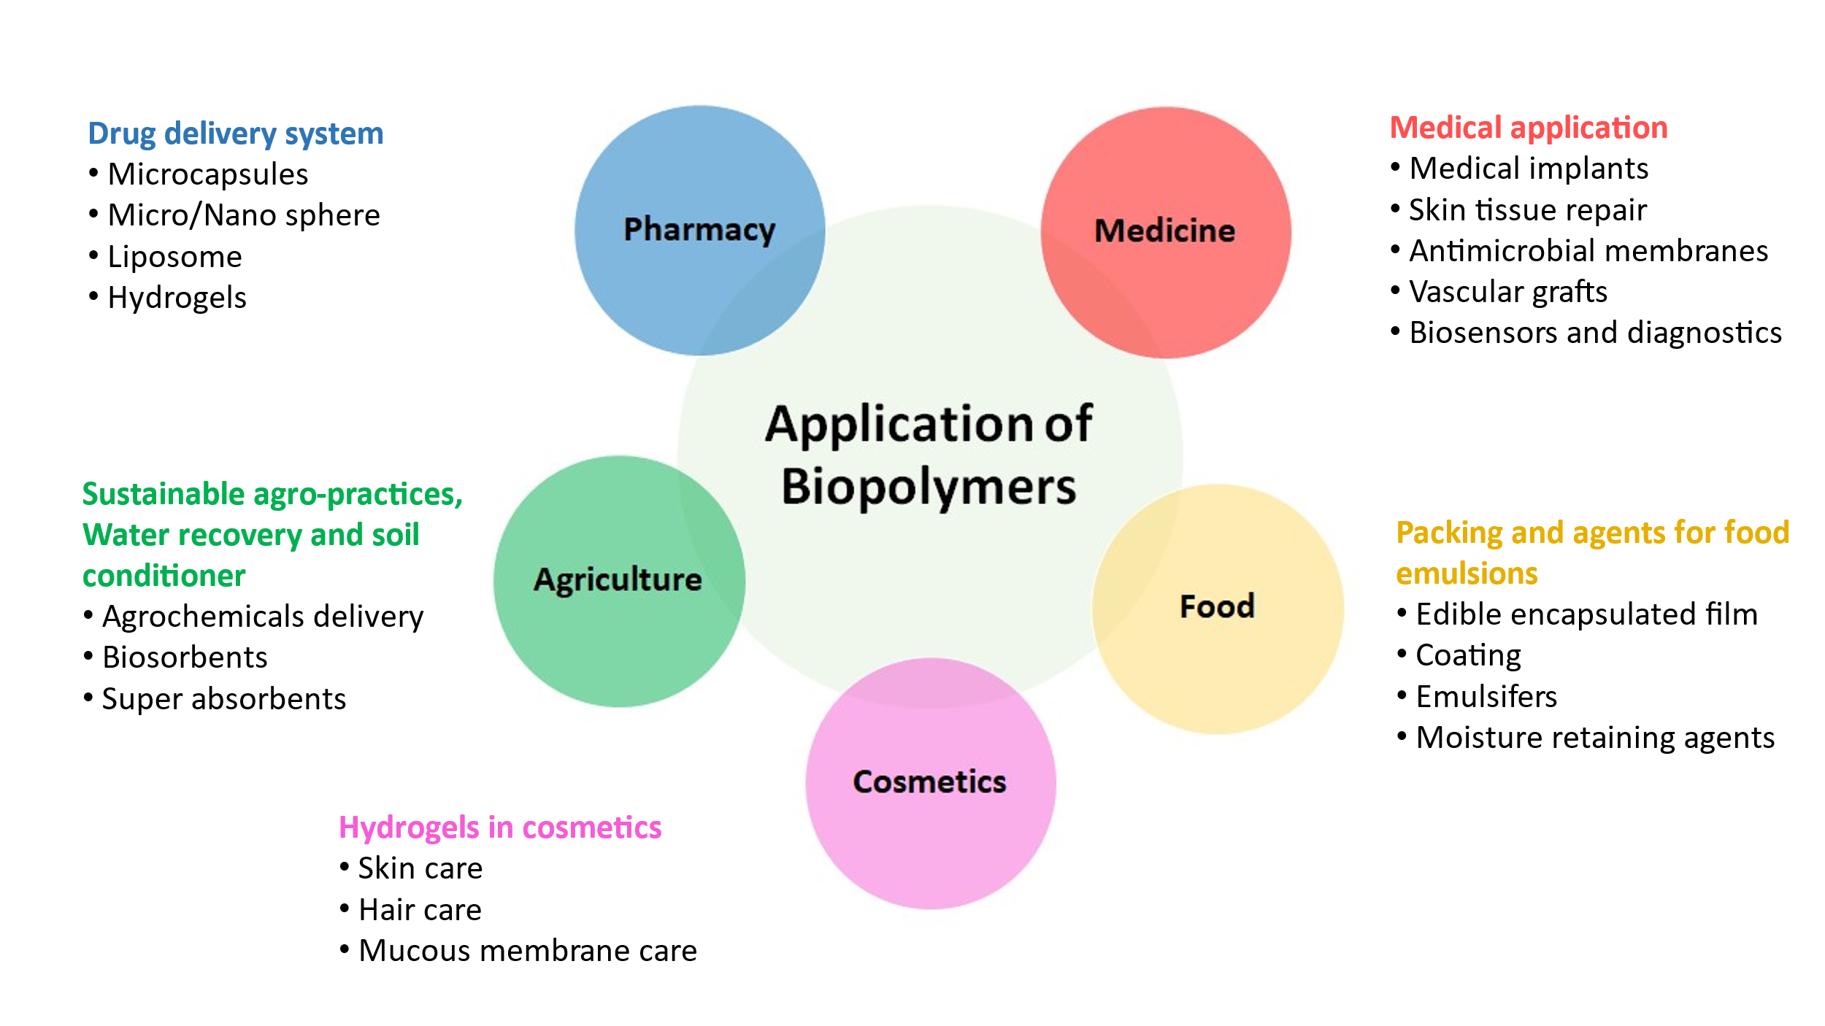 Bio-sensors
- These are devices that are used to measure many different parameters such as analyte concentrations. They are used for diverse purposes such as analysis, toxicology, medical diagnosis, environmental monitoring, and others .
- A typically biosensor consists of a bio-receptor (enzyme/antibody/ cell/ nucleic acid/aptamer), transducer component (semi-conducting material/nanomaterial), and electronic system which includes a signal amplifier, processor & display.
- Bio-receptor interaction is measured by the biotransducer which outputs a measurable signal proportional to the presence of the target analyte in the sample.
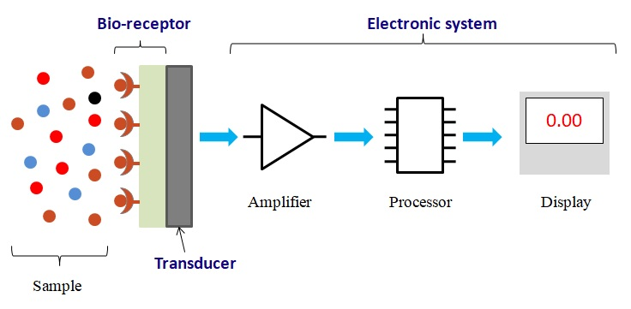Main components of Bio-sensor
Bio-chips
- Bio-chips are miniaturized laboratories in which thousands of biochemical reactions can be carried out simultaneously at micron scales for useful purposes such as disease studies or safety studies.
- Biochips are engineered substrates underlying sensor technology.
Bio-filters
- Biofilters are technical applications that use the biofiltration process to remove pollutants in environment.
- Biofiltration is a pollution control technique using a bioreactor containing living material to capture and biologically degrade pollutants.
- It is application are used to remove the pollutants from air and water.
- Some examples of biofiltration: Slow sand filters, Treatment ponds, Constructed wetlands and natural wetlands. Filters like Bioswales, biostrips, biobags, bioscrubbers, Vermifilters and trickling filters.
Bio-pesticides
- Bio-pesticides are biological substances or organisms that can be used instead of chemicals for pest control and thus they overcome the negative effects of chemical pesticides.
- The effective control of bio-pesticides requires appropriate formulation and application.
- Bio-pesticides are majorly used in the area of soil amendments and seed treatments.
Concrete Self-heal
- Organisms can be used to make concrete self-heal its cracks due to wear-and-tear. For example, some bacteria (alkali-tolerant bacteria species such as Bacillus pseudofirmus) can catalyse the formation of calcium carbonate in their surroundings under appropriate conditions.
When this happens in cracks that are formed in the concrete, the microscopic cracks are filled with the calcium carbonate formed with the help of the bacteria, which can effectively seal the cracks, and thus effect self-healing of the concrete
Seminar 2 Theme Biochemistry of individual products of fermentation
- Lactic acid
- Hydrogen gas
- Alternative protein
- Enzymes
Seminar 3. Theme Upstream processing in fermentation Scale up of Fermentation.
SCALE UP OF FERMENTATION
modeling methods of FERMENTATION
OPTIMIZING SCALE-UP FERMENTATION PROCESS

Various modeling methods are used including
- Chemical similitude studies
- Mathematical modeling
- Finite elemental analysis
- Computational fluid dynamics
1) Chemical similitude studies:
Computer aided modeling and simulations in the development, intergration optimization of the industrial process.
compounds clean and weeded.

Seminar 4. Theme The types of microbial fuel cell. Mediated MFC. Mediator-free microbial fuel cells Microbial electrolysis. A soil-based MFC. Phototrophic biofilm. Nanoporous membrane. Applications in of MFC in environmental RemediationPrimary and Secondary screening of industral important microbes.

Seminar 5 Theme Industrial important algae, fungi yeasts
Some important microbial enzymes and their application
Using algae for Biofuels, such as biodiesel
Using algae for Wastewater treatment
Using Virus for drugs and other pharmaceuticals
Organisms and method for amino acid production
-
Seminar 6. Fungal biodegradation. Cholesterol biodegradation. Analysis of waste biotreatment.

Aerobic biodegradation of pollutants. Anaerobic biodegradation of pollutants
Types of of xenobiotics: Petroleum products, aliphatic and aromatic hydrocarbons, solvents, pesticides and metals
Many synthetic steroidic compounds like some sexual hormones frequently appear in municipal and industrial wastewaters, acting as environmental pollutants with strong metabolic activities negatively affecting the ecosystems. Since these compounds are common carbon sources for many different microorganisms their aerobic and anaerobic mineralization has been extensively studied. The interest of these studies lies on the biotechnological applications of sterol transforming enzymes for the industrial synthesis of sexual hormones and corticoids.

Seminar 7. Theme. Common molds used for pharmaceuticals. Food production
molds that have been used in food production include:
- Fusarium venenatum – quorn
- Geotrichum candidum – cheese
- Neurospora sitophila – oncom
- Penicillium spp. – various cheeses including Brie and Blue cheese
- Rhizomucor miehei – microbial rennet for making vegetarian and other cheeses
- Rhizopus oligosporus – tempeh
- Rhizopus oryzae – tempeh, jiuqu for jiuniang or precursor for making Chinese rice wine
Several statin cholesterol-lowering drugs (such as lovastatin, from Aspergillus terreus) are derived from molds.

Seminar 8. Theme. Genetically modified organisms such as fungi, viruses, plants, crops, animals, fish, gene therapy and for bioremediation
Viruses are often modified so they can be used as vectors for inserting genetic information into other organisms. This process is called transduction and if successful the recipient of the introduced DNA becomes a GMO. Different viruses have different efficiencies and capabilities. Researchers can use this to control for various factors; including the target location, insert size, and duration of gene expression. Any dangerous sequences inherent in the virus must be removed, while those that allow the gene to be delivered effectively are retained
Fungi can be used for many of the same processes as bacteria. For industrial applications, yeasts combine the bacterial advantages of being a single-celled organism that is easy to manipulate and grow with the advanced protein modifications found in eukaryotes. They can be used to produce large complex molecules for use in food, pharmaceuticals, hormones, and steroids.

Seminar 9. Theme. Plant Metabolic Engineering
Approaches to Plant Metabolic Engineering
A number of approaches are used for secondary metabolites improvement using bacteria in metabolic engineering, such as
(1) heterologous expression of gene clusters
(2) regulatory networks pathway engineering.
(3) gene insertion or deletion
(4) stimulation using certain substrates.

Seminar 10. Theme. Examples using biochemical engineering for developing products and processes.

Biochemical engineering, also known as bioprocess engineering, is a field of study with roots stemming from chemical engineering and biological engineering. It mainly deals with the design, construction, and advancement of unit processes that involve biological organisms (such as fermentation) or organic molecules (enzymes) and has various applications in areas of interest such as biofuels, food, pharmaceuticals, biotechnology, and water treatment processes.
Some commonly processed foods include wheat, fruits, and milk which undergo processes such as milling, dehydration, and pasteurization to become products that can be sold. There are three levels of food processing: primary, secondary, and tertiary.

Seminar 11. Theme. Biomolecular engineering for manipulation of carbohydrates, proteins, nucleic acids and lipids. These procedures occur within the framework of the relation between their structure) and properties and in relation to applicability to such areas as environmental remediation, crop and livestock production, biofuel cells and biomolecular diagnostics.
The thermodynamics and kinetics of molecular recognition in enzymes, antibodies, DNA hybridization, bio-conjugation/bio-immobilization and bioseparations are studied. Attention is also given to the rudiments of engineered biomolecules in cell signaling, cell growth kinetics, biochemical pathway engineering and bioreactor engineering.

Seminar 12. Theme. Examples using immobilization of enzymes and cells for improving products and processes proprties.

Enzymes as a desired product.

Industrial enzymes

Selection of a suitable enzyme

Identification and selection of a suitable source for the selected enzyme

Process development

Large scale production

Downstream

Seminar 13. Theme. Antioxidants. Nonsynthetic compounds for food preservation. Techniques used for food preservation.
The oxidation process spoils most food, especially those with a high fat content. Fats quickly turn rancid when exposed to oxygen.
Antioxidants prevent or inhibit the oxidation process. The most common antioxidant additives are ascorbic acid (vitamin C) and ascorbates. Thus, antioxidants are commonly added to oils, cheese, and chips.
Other antioxidants include the phenol derivatives BHA, BHT, TBHQ and propyl gallate. These agents suppress the formation of hydroperoxides.

Seminar 14. Cell Engineering for adjustment of cell properties, augmenting cells to produce new products

Examples of application cell engineering
- TherapeuticT cell engineering:[ altering T cells to target cancer-related antigens for treatment
- Monoclonal antibody production: improving monoclonal antibody production using engineered cells
- In vivo cell factories: engineering cells to produce therapeutics within the patient's body
- Directed stem cell differentiation: using external factors to direct stem cell differentiation
- Antibody Drug Conjugates:engineering antibody and cytotoxic drug linkages for disease treatment

Seminar 15. Tissue Engineering

Tissue engineering in situ
tissue regeneration is defined as the implantation of biomaterials (alone or in combination with cells and/or biomolecules) into the tissue defect, using the surrounding microenvironment of the organism as a natural bioreactor.This approach has found application in bone regeneration, allowing the formation of cell-seeded constructs directly in the operating room

